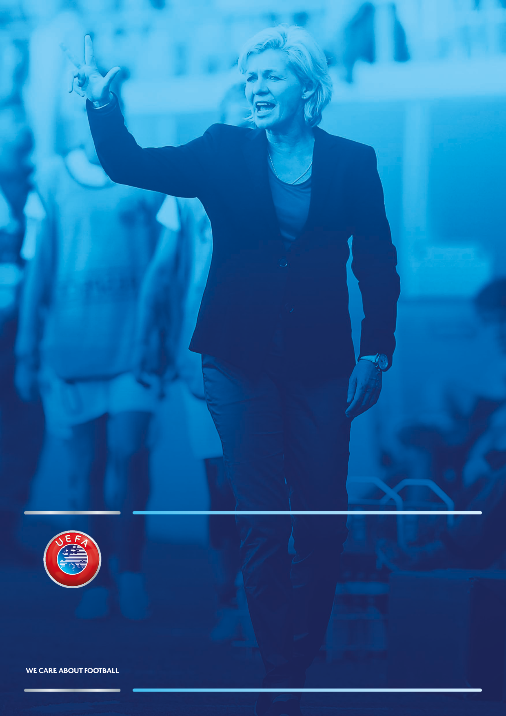
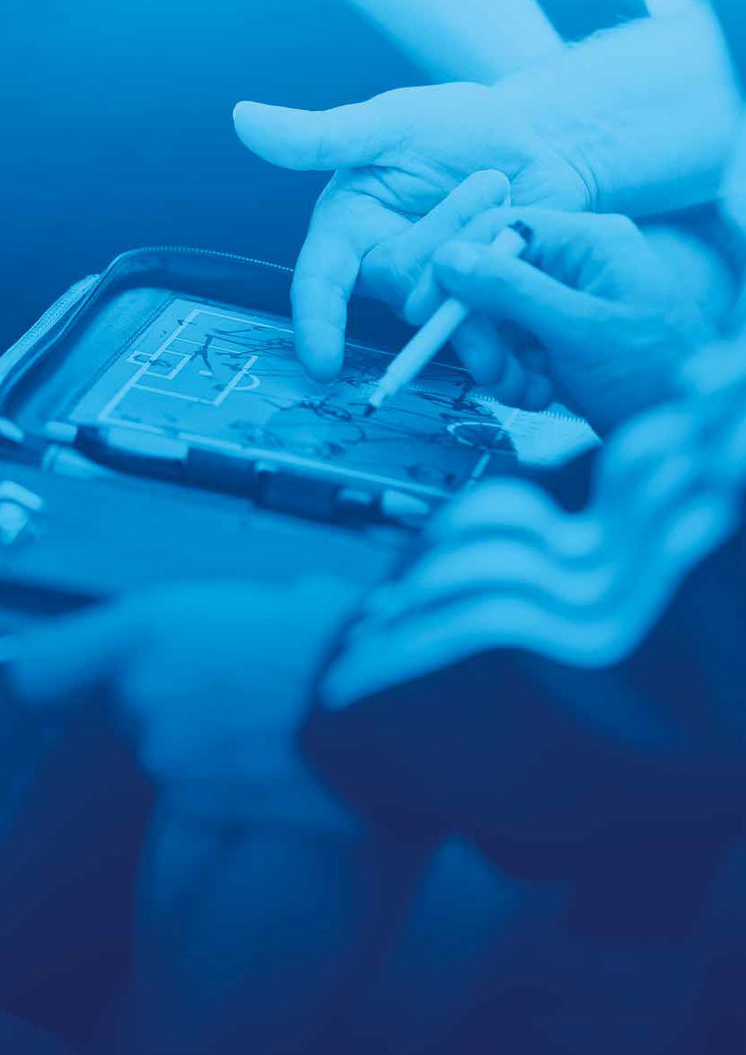
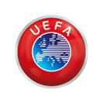

UEFA Coach Development Project for Women

UEFA B diploma: CV
Please complete one CV per candidate and return it to the UEFA administration (Yolande Kämpfer-Seewer: Yolande.Kaempfer-Seewer@uefa.ch) by Friday 1 February 2019.

Personal details
Surname | Surname | First name | First name
Date of birth | DD/MM/YYYY | Nationality | Nationality
Phone (landline) or mobile | Phone/mobile number | Street | Street
Email | Email | Town | Town

Please insert a headshot photo here.



Coach education
C licence
Year |  |  | Licence number |  |  | Expiry date

Experience

Professional experience
Year |  | Position |  |  |  |  |  |  | Company
Year |  | Position |  |  |  |  |  |  | Company
Coaching experience
Year | Club |  |  | Role (head coach, ass. coach, etc.) |  |  |  | Professional club ☐ |  | Amateur club☐
Year | Club |  |  | Role (head coach, ass. coach, etc.) |  |  |  | Professional club ☐ |  | Amateur club☐
Year | National team |  |  | Role (head coach, ass. coach, etc.)
Playing experience (club)
Year |  | Club |  | Professional club ☐ |  |  | Amateur club☐
Year |  | Club |  | Professional club ☐ |  |  | Amateur club☐
Playing experience (national team)
Country |  | No. of international caps |  |  |  |  |  | WU17
 |  | No. of international caps |  |  |  |  |  | WU19
 |  | No. of international caps |  |  |  |  |  | A team

Declarations

Coach’s declaration
I confirm that the above information is correct to the best of my knowledge. Moreover, I undertake to complete the UEFA B diploma course and to coach for at least one full season as a UEFA B licence holder if a suitable position is offered to me.

Place and date: Place and Date

Signature:

National association’s declaration
I confirm that the information provided by Name and Surname is correct to the best of my knowledge. In addition, I guarantee that all 120 hours of tuition will be provided and I agree to use my best efforts to find a suitable coaching position for the candidate should she not have one on receipt of her diploma.

Place and date: Place and Date

Name of technical director: Name

Signature of technical director:

Contact details
Please send this CV to:

Yolande Kämpfer-Seewer
Women Coaches Development Specialist
Yolande.Kaempfer-Seewer@uefa.ch
+41 22 707 28 77 (office)
+41 79 829 28 77 (mobile)




UEFA
Route De Genève 46
CH-1260 Nyon 2
Switzerland
Telephone: +41 848 00 27 27
Telefax: +41 848 01 27 27
UEFA.org

